ASE LAB 2 ASSIGNMENT REPORT

I created a mobile application using JS Fiddle, JQuery Mobile (JavaScript), Html, CSS for Lab 2 Assignment.

This Client application can be used for getting weather report. This serves for getting current weather (temperature) of Kansas City. This also shows the weather condition like rainy, snowy or sunny. Weather API’s are used to get weather report.

Screenshots of the application are:

1. The home page of application is displayed as below. To get weather report we need to click the Get Weather Report option.

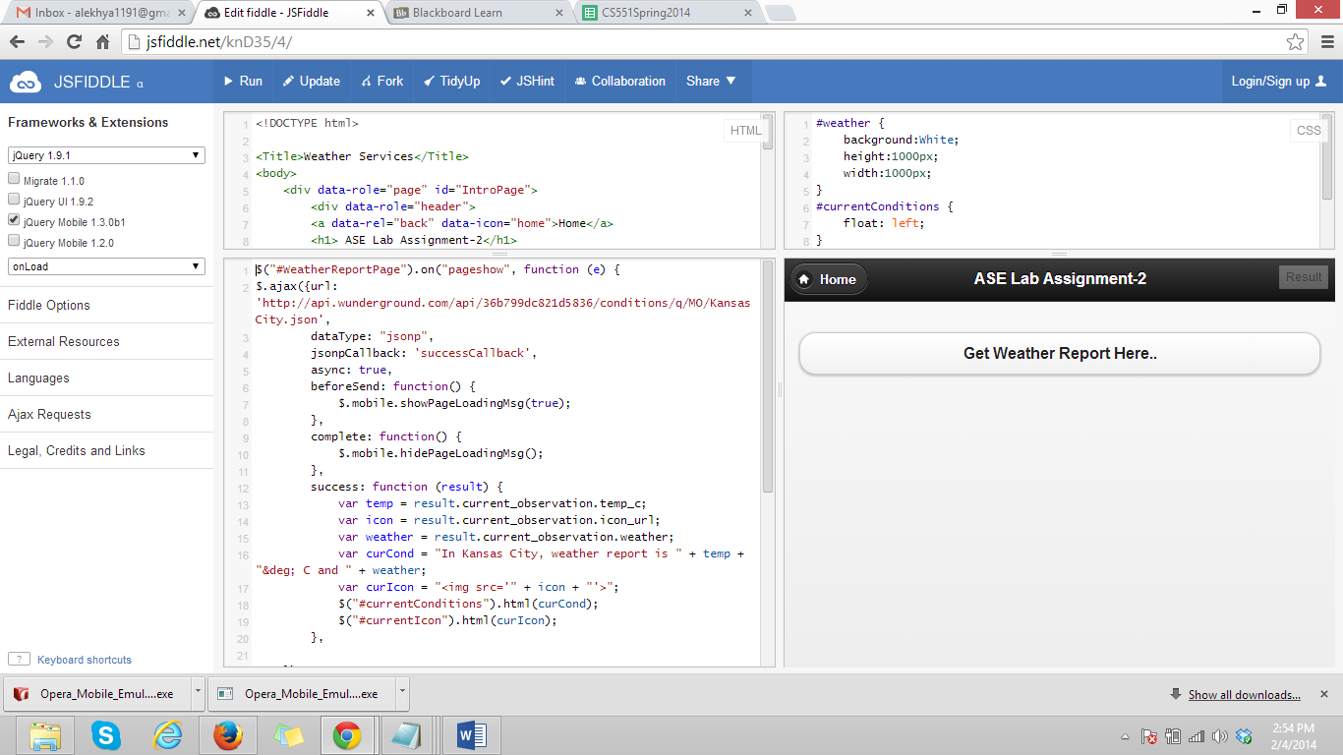

1. After weather report tab is selected, the current weather condition and temperature is shown.

